Retail Sales Trend Monitoring Project

📌 Project Overview
This project aims to help a retail chain monitor stores with increasing sales trends.
We use time-series sales data to detect upward trends using linear regression and visualize them through a Streamlit dashboard.

📘 Sample Data
Sample of the sales_data.csv file:
store_id date sales
101 2023-01-01 1500
101 2023-01-02 1600
101 2023-01-03 1700
101 2023-01-04 1800
101 2023-01-05 1900

📓 Trend Detection Using Linear Regression
We calculate the sales trend for each store using linear regression:
Trend detection result:
store_id slope trend
101 100.0 Increasing
102 -50.0 Decreasing

📊 Example Trend Plot
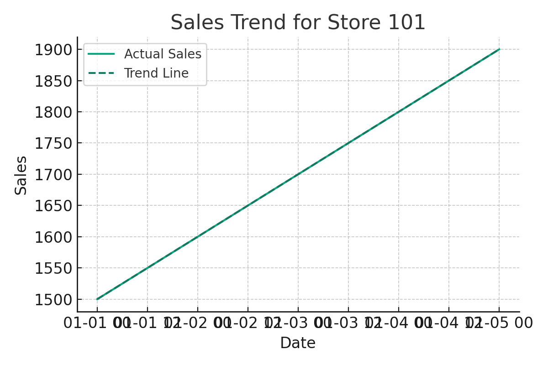

🚀 Streamlit Dashboard Code
Below is the code for the Streamlit dashboard:
import streamlit as st
import pandas as pd
import matplotlib.pyplot as plt
from sklearn.linear_model import LinearRegression
df = pd.read_csv('sales_data.csv', parse_dates=['date'])
trends = pd.read_csv('store_trends.csv')
st.title("📈 Store Sales Trend Monitor")
store_ids = df['store_id'].unique()
selected_store = st.selectbox("Select a store", store_ids)
store_data = df[df['store_id'] == selected_store].copy()
store_data['day_num'] = (store_data['date'] - store_data['date'].min()).dt.days
X = store_data[['day_num']]
y = store_data['sales']
model = LinearRegression().fit(X, y)
predicted = model.predict(X)
fig, ax = plt.subplots()
ax.plot(store_data['date'], y, label='Actual Sales')
ax.plot(store_data['date'], predicted, label='Trend Line', linestyle='--')
ax.set_title(f"Sales Trend for Store {selected_store}")
ax.set_xlabel("Date")
ax.set_ylabel("Sales")
ax.legend()
st.pyplot(fig)
trend_info = trends[trends['store_id'] == selected_store]
if not trend_info.empty:
st.markdown(f"### 📊 Trend: **{trend_info.iloc[0]['trend']}**")

